***PROJECT DOCUMENT***

***Cookbook: Your Virtual Kitchen Assistant.***

**1.Introduction**

* **Project Title:** Cookbook: Your Virtual Kitchen Assistant.
* **Team ID:** NM2025TMID37112
* **Team Leader:** Harini S & harinisaravanarajan@gmail.com
* **Team Members:**

Kaviya R &

Agila S & agilasakthi0@gmail.com

Hemapriya S & hemakirthu2006@gmail.com

**2.Project Overview**

* **Purpose:** SB Works connects clients and freelancers through project postings, bidding, and real-time communication.

Project overview for a "cookbook" can either describe a physical or digital collection of recipes for home cooks, or it can refer to a collection of configuration and policy distribution methods in a systems automation framework like Chef Infra. In the context of a physical/digital recipe cookbook, the overview summarizes the project's purpose, target audience, scope, and goals, such as creating a visually appealing and accessible collection of recipes for home cooks. For Chef Infra's "cookbooks," the project overview, or metadata.rb, describes the cookbook's contents, dependencies, and purpose in a system automation scenario.

* **Features:**

A feature in a cookbook can refer to design elements such as photos, sidebars, and pull quotes that enhance usability, or functional additions like meal plans, shopping list generators, and recipe scaling tools, depending on whether it's a physical book or a recipe management app. Alternatively, in software like Chef Infrastructure, a cookbook is a configuration file containing recipes, attributes, and other components that define how a system should be set up and managed.

A cookbook or cookery book is a culinary reference work that contains a collection of recipes and instructions for food preparation. Cookbooks serve as comprehensive guides that may include cooking techniques, ingredient information, nutritional data, and cultural context related to culinary practices.

**Features in a Physical Cookbook**

**High-Quality Photography**: Features like finished dish photos, how-to images, and close-ups of food texture can make a recipe appealing and easier to follow.

**Clear Organization**: Ingredients listed first and in order, concise instructions, and the use of common culinary terms make recipes easy to use.

**Design Elements**: Sidebars with tips or anecdotes, pull quotes, and a visually appealing layout improve navigation and can add context or personality to the book.

**Cultural Context**: Some cookbooks may include stories, lore, or historical background to enrich the culinary experience.

1. ***Project posting and bidding***

The "project posting and bidding process" is a multi-stage procurement system where a project owner defines a project, solicits bids from potential vendors, receives their proposals, and selects the best offer to award a contract. Key stages include pre-bid planning, releasing tender documents, vendor bid submission, bid evaluation against set criteria, and ultimately awarding the contract. The goal is to find the most qualified vendor who offers the best value for money for the project.

Stages of the Project Posting & Bidding Process

Pre-Tender Stage / Bid Solicitation:

Project Definition: The client or owner defines the project's scope, requirements, and specifications.

Documentation: Prepare comprehensive bid documents, including the Request for Proposal (RFP) or Invitation to Bid (ITB).

Vendor Identification: Identify potential vendors or suppliers who are qualified to complete the project.

Tendering Stage / Bid Submission:

Tender Invitation: The project owner officially invites potential vendors to submit their bids by releasing the tender documents.

Bidder Briefings: Attend pre-bid briefings to clarify any uncertainties and understand the project's requirements fully.

Bid Preparation: Vendors prepare their bids, which include detailed proposals, pricing, timelines, and necessary documentation.

Bid Submission: Bids are submitted by the deadline in the specified format and to the correct location.

Post-Tender Stage / Bid Evaluation:

Compliance Check: Each bid is first checked for compliance with the tender requirements.

Evaluation: Compliant bids are evaluated against the pre-determined criteria specified in the tender documents, such as cost, technical capability, and past performance.

Selection: The bid that offers the best value for money, often the lowest responsive evaluated bid (or MEAT - Most Economically Advantageous Tender), is selected.

Post-Contract Stage / Award:

Awarding the Contract: A contract is awarded to the successful vendor.

Project Delivery: The vendor delivers the goods, services, or works according to the agreed-upon contract terms.

1. Secure chat system

Testing & Deployment: Test the system for security vulnerabilities and performance, then deploy it.

Advanced Features (Optional)

Message Integrity: Ensure messages haven't been tampered with.

Forward Secrecy: A temporary session key is generated for each conversation, so if a long-term key is compromised, past messages remain secure.

Media Encryption: Apply similar encryption to voice and image messages.

1. Feedback and review system

A cookbook feedback and review system project involves building a web application where users can rate, comment on, and share their experiences with recipes from a digital cookbook. Key features often include recipe categorization, user profiles, star ratings, text comments, sentiment analysis for feedback, and administrative dashboards to manage content. Tools like HTML, CSS, JavaScript for the front-end, and backend technologies such as Java, PHP, or Python with frameworks like Django, along with databases like MySQL, are commonly used to develop such systems.

Project Objectives

User Engagement: Allow users to interact with recipes, encouraging more engagement with the platform.

Recipe Improvement: Collect feedback to help authors and publishers refine and improve recipes.

Personalized Discovery: Help users find recipes that match their tastes by leveraging user ratings and comments.

Community Building: Create a space where users can share their cooking experiences and build a community.

Key Features to Consider

User Management: Registration, login, and user profiles.

Recipe Display: Browse recipes by category, view recipe details, and see user ratings.

Feedback & Ratings: Allow users to leave star ratings and textual comments on recipes.

Sentiment Analysis: Automatically analyze user comments to understand overall sentiment (positive, negative).

Recipe Posting: Enable users to contribute their own recipes to the system.

Admin Dashboard: A backend interface for administrators to manage recipes, users, and review content.

Technologies & Tools

Front-end: HTML, CSS, JavaScript, Bootstrap.

Back-end: Java (with JSP/Servlet), PHP, Python (with Django).

Database: MySQL, PostgreSQL.

Libraries/Frameworks: JQuery, Maven, LangChain (for AI-assisted feedback).

APIs: YouTube APIs for retrieving video comments (if integrating video content).

Potential Enhancements

Personalized Recommendations: Suggest recipes based on a user's past ratings and preferences.

Advanced Data Analytics: Utilize data mining techniques and machine learning to provide deeper insights from feedback.

Mobile App Integration: Develop a mobile application for easier access and user experience on the go.

AI-Assisted Feedback Analysis: Use Large Language Models (LLMs) to process and understand user feedback more effectively.

1. Admin control panel

The document outlines proposed features and improvements for an admin panel, including the addition of a feedback section, email notifications for reported users, and new statistics on user activity and subscriptions. It also requests clarification on the least used features and provides a format for reporting user subscriptions and activities. Additionally, it mentions the need for a detailed report on user engagement metrics such as daily and monthly active users.

3. Architecture:

An architecture glossary in cookbook words list could feature terms like Façade, Floor plan, Fenestration, Cantilever, Coffer, Arbor, Arch, Balustrade, and Cladding, describing design and structural components with a user-friendly, descriptive approach akin to a recipe's ingredient list or cooking terms.

Here is a list of architecture terms that could be found in a cookbook, using descriptive, approachable language:

Components & Features

Baluster (A small post in a railing, like individual decorative elements supporting a structure)

Balustrade (A row of balusters supporting a railing, or a decorative border for a tiered cake)

Cladding (Components attached to a building's structure, like protective outer layers of a pie)

Canopy (An overhead structure providing shelter, similar to a protective lid for a dish)

Advanced Concepts

Arbor: (A curved structure, like an elegant arrangement of ingredients)

Biomimicry: (Incorporating nature's designs into architecture, like using natural flavors in a dish)

Vernacular: (Architecture that is local or traditional, like regional cuisine passed down through generations)

* Frontend: React.js with Bootstrap and Material UI

In cookbook terms, the "front end" is the introduction and upfront sections of the book, including the title page, author's preface, table of contents, list of recipes, and any explanations of how to use the book or the specific rules for the recipes within it. It's the material a reader encounters first, setting the stage and providing essential information before diving into the recipes themselves.

Elements of a Cookbook's "Front End"

Title Page: Displays the book's title.

Copyright Page: Contains legal information about the book.

Dedication: The author's dedication to someone.

Epigraph: A short quotation placed at the beginning of a book.

Table of Contents: Lists the chapters and sections, often including a list of recipes by category.

List of Illustrations/Recipes: Provides an overview of the visual elements and recipes in the book.

Foreword/Preface: An introduction written by someone other than the author (foreword) or by the author themselves to explain the background and purpose of the cookbook.

How to Use the Book: Instructions on how to interpret the recipes, such as defining terms or explaining cooking techniques.

Introduction: The author's personal message, sharing their connection to the recipes, the cookbook's background, and potentially information on special equipment or cooking times.

* Backend: Node.js and Express.js managing server logic and API endpoints.

In cookbook terms, the backend is like the ingredients, kitchen appliances, and storage area that make a meal possible, but aren't the final dish itself. It's the "server" and "database" working behind the scenes to store, process, and organize everything.

Here's a breakdown using cooking analogies:

Front End (The User Experience): This is what you see and interact with directly, like the final plated dish at the dining table.

Back End (The Engine Room): This is everything hidden from the diner's view that makes the meal happen:

Ingredients: The raw data that the application needs to work.

Appliances & Utilities: The server and database that store, process, and manage the data.

The Chef's Prep: The logic and code that handle requests, transform ingredients, and ensure everything is put together correctly.

The Kitchen: The physical or cloud-based infrastructure where everything operates.

Example in a Recipe context:

When you order a dish at a restaurant, the front end is the menu you see and the food that arrives on your plate. The back end is everything happening in the kitchen: the ingredients in storage, the chef's techniques for preparing them, the equipment used to cook, and the database that manages inventory.

* Database: MongoDB stores user data, project information, applications, and chat messages.

English, a "database" refers to a structured collection of data, while a "cookbook" is a book containing recipes and instructions for cooking food, or in a technical sense, a collection of instructions for configuring and policy distribution in a software system like Chef Infra. Therefore, "database cookbook words in English" could refer to the specific technical terms used in software cookbooks for managing data, or to any vocabulary encountered within a physical recipe book for cooking.

General Cooking Vocabulary

If you're looking for words related to a physical cookbook, here's some common culinary vocabulary:

Recipe: A set of instructions for preparing and cooking food, including a list of ingredients.

Ingredients: The items used in a recipe.

Utensils/Tools: Items used for cooking, such as knives, bowls, and pans.

Techniques: The methods used in cooking, like slicing, frying, boiling, or baking.

Quantities: The amounts of ingredients, such as a pinch, teaspoon, or dash.

Technical Cookbook Vocabulary

If you are referring to the technical term "cookbook" in relation to databases, here are some examples of words you might find:

Configuration: The settings and parameters that define how a database or a system operates.

Policy: A set of rules and guidelines that govern the behavior of the database or system.

Recipes (technical): In a software cookbook, these are the instructions written in a specific language to define actions for the system, like setting up a database.

Resources: The fundamental built-in components of the system that the recipes can manipulate, such as a file or a service.

4. Setup Instructions

* Prerequisites:

-Node.js

-MongoDB

-Git

-React.js

-Express.js –Mongoose- Visual Studio Code

* Installation Steps:

# Clone the repository git clone

# Install client dependencies cd client npm install

# Install server dependencies cd ../server npm install

* 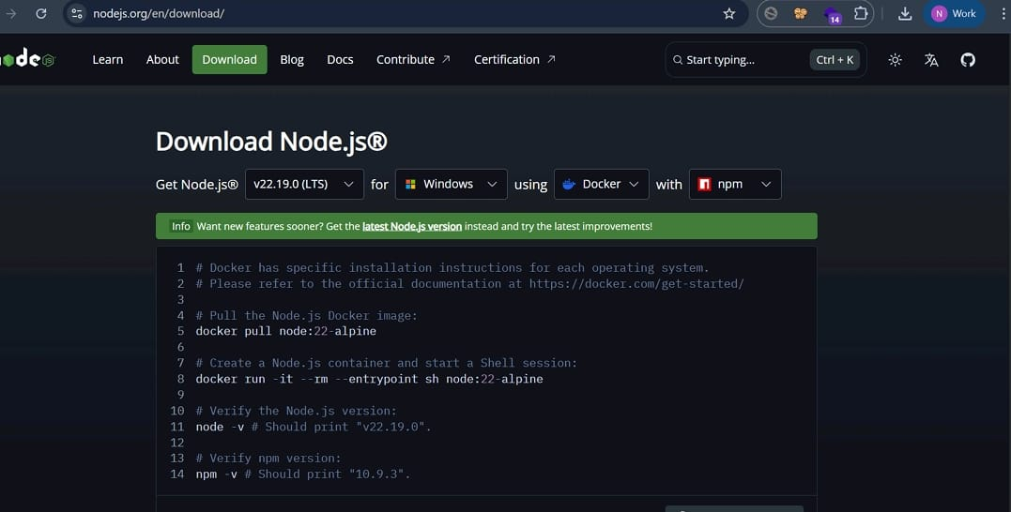Download Node.js LTS version from <https://nodejs.org/en/download/>
* Select your system configuration and click on
* Windows installer(.msi) if windows

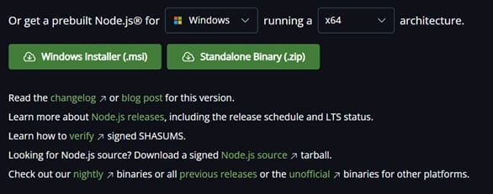

Or

* macOS installer (.pkg) if macOS

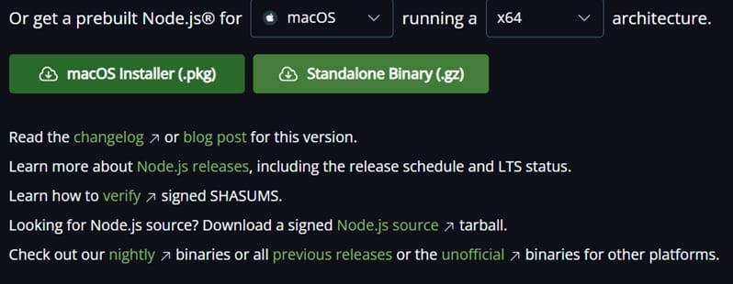

* 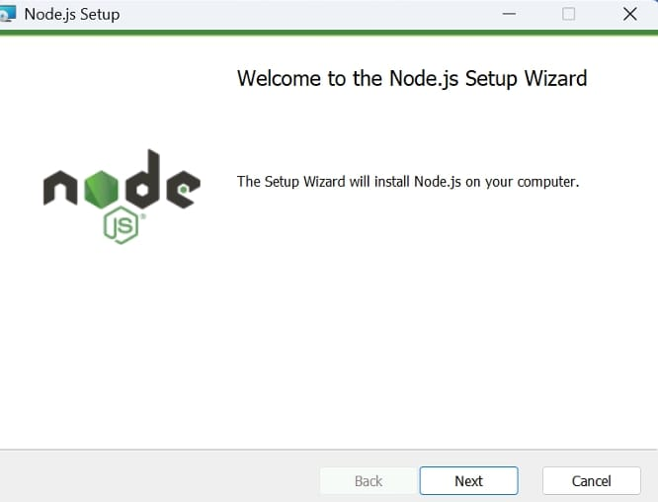After downloading, install Node.js by opening the downloaded file and follow the instructions below.

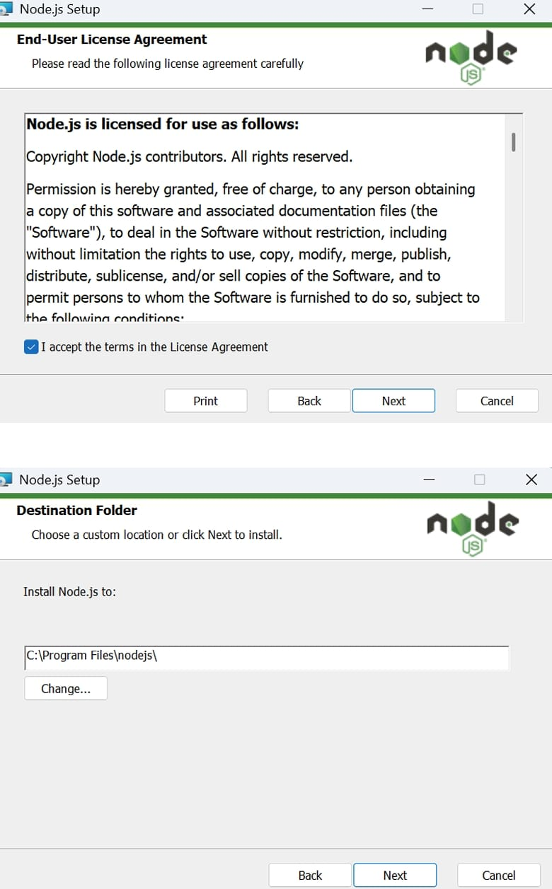

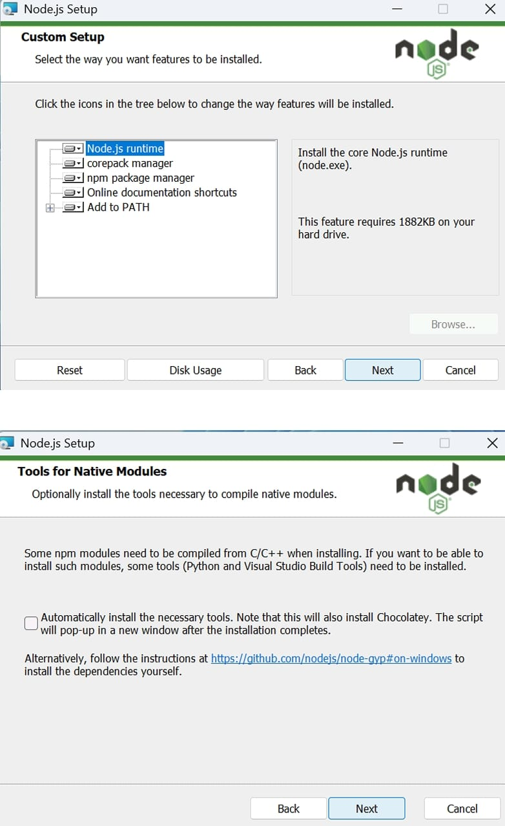

* 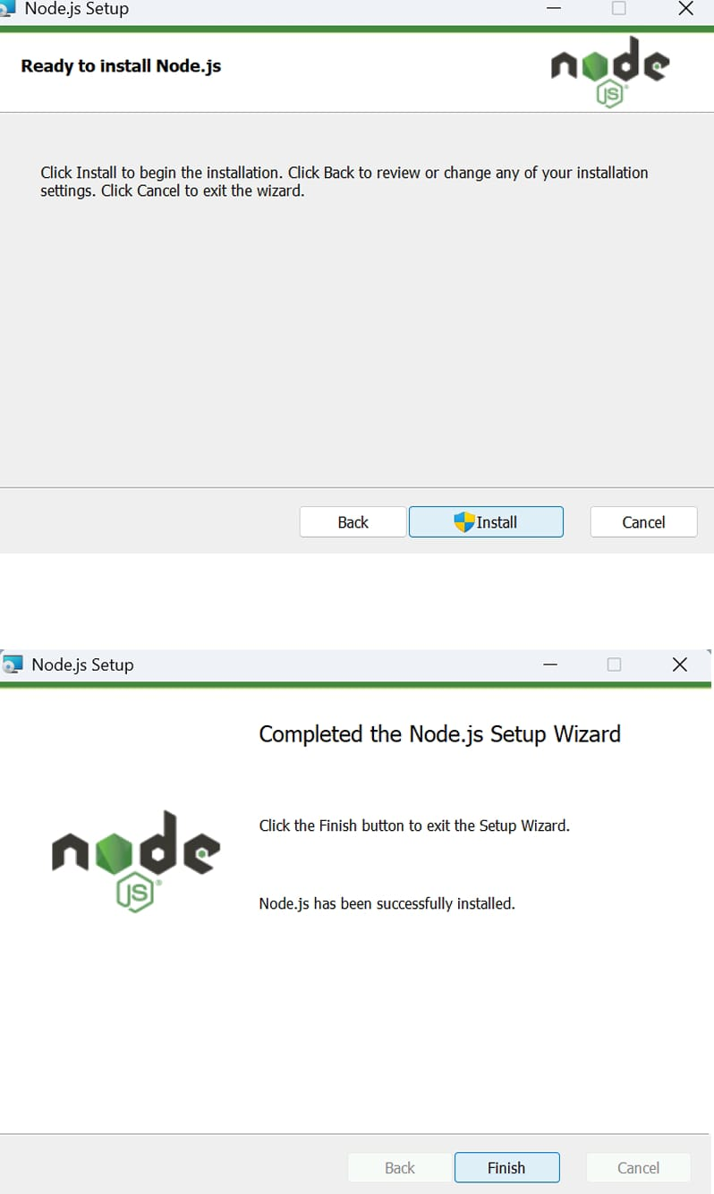After installing Node.js, open Windows PowerShell As 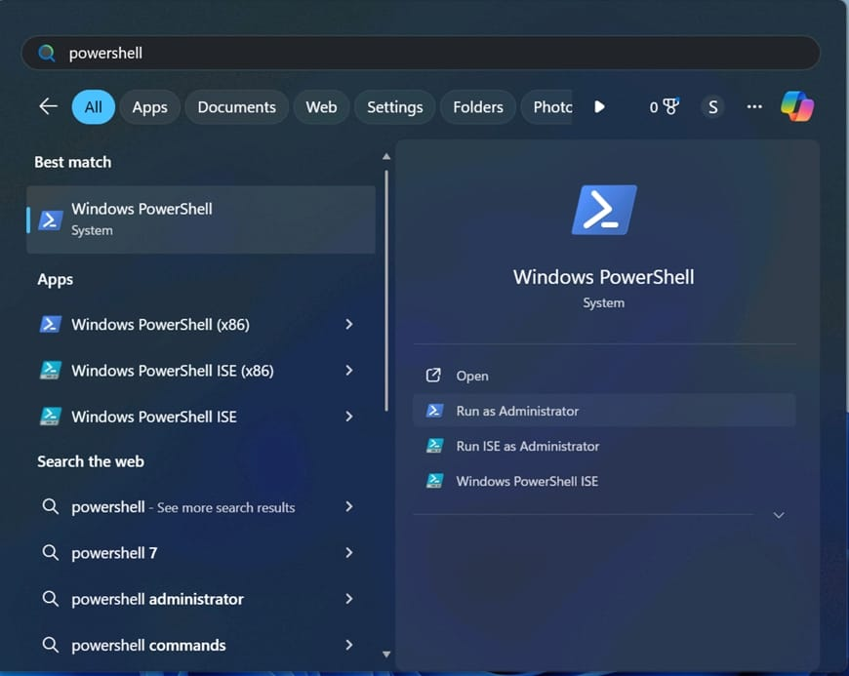Administrator.
* Type set-executionPolicy unrestricted and press enter

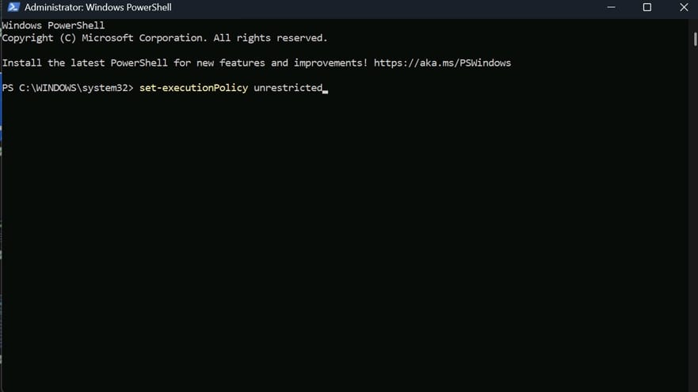

* 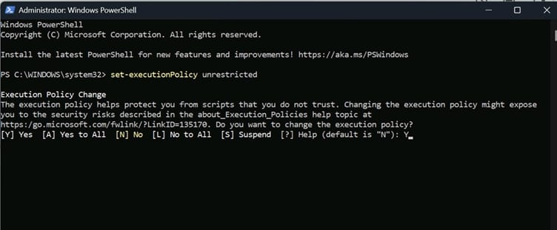In the next step type Y and press enter.

Steps To Download And Execute Project:

● From your SmartInternz portal GoTo Projects → Access Resources → Guided Projects → Go To Workspace

● Inside Guided Project you can find Project Flow

● Now you can see two links one is the demo video and the other is the code drive link.

● Click on the code drive link or copy paste that link in your new chrome tab.

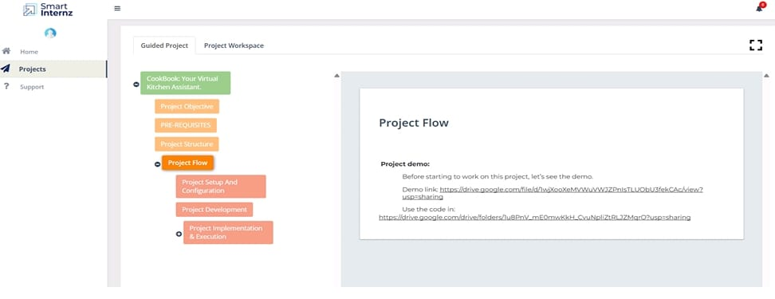

* 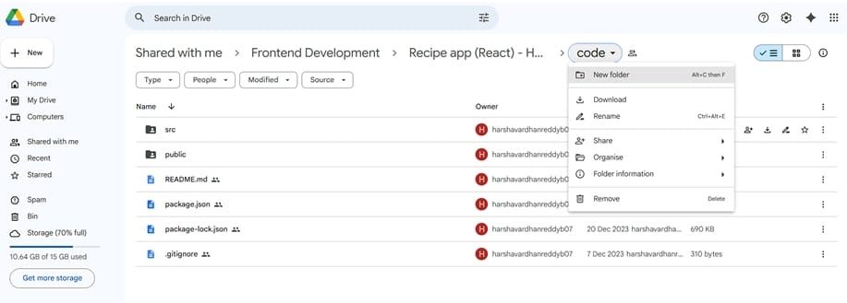Download the code folder.
* Now go to downloads and right click on the downloaded zip folder and click on extract all.

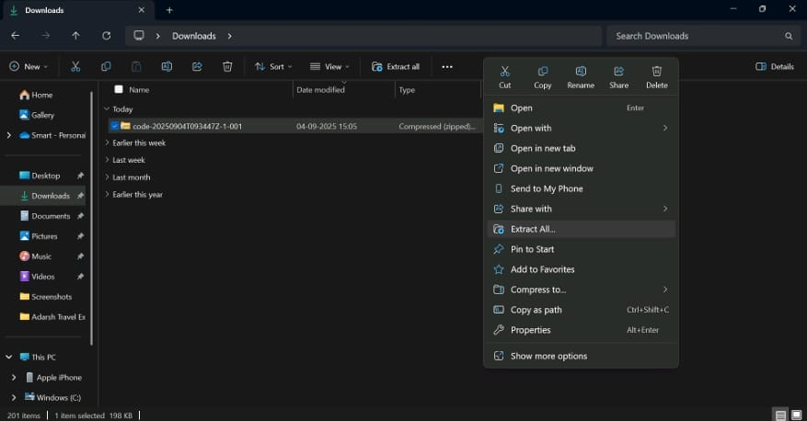

* Now click on Extract.

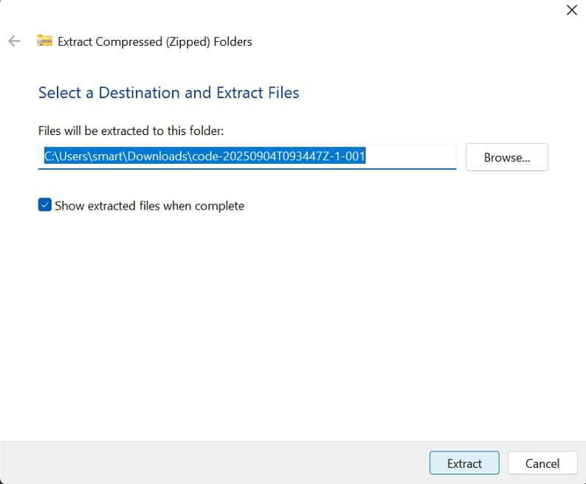

* 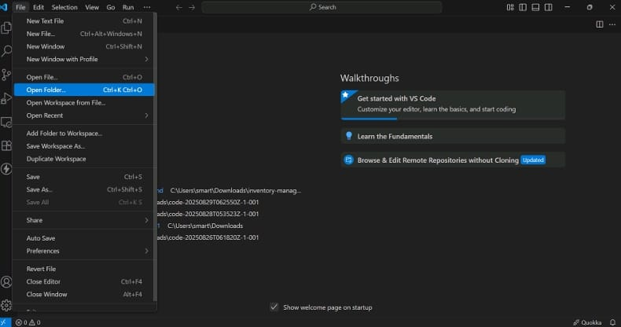Now open VS code and open the code folder from the extracted folder.

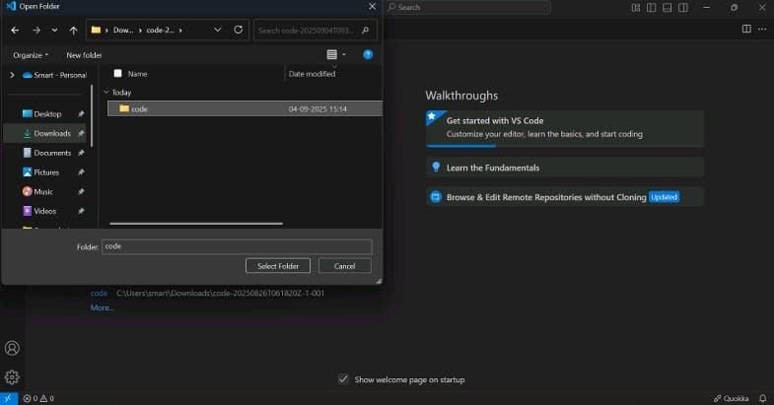

* Now open a new terminal.

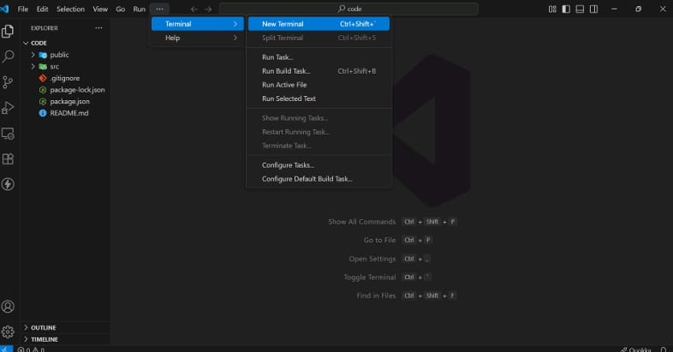

* 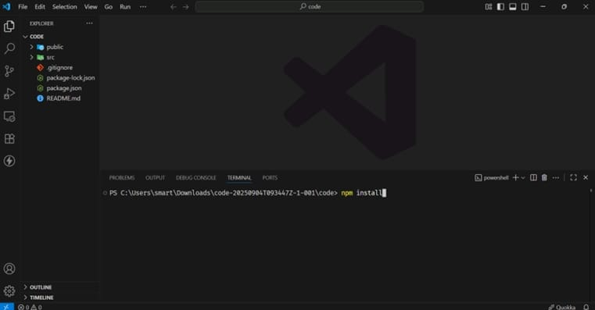Type npm install in your terminal and press Enter and wait till all the dependencies gets download
* After all the downloads finishes, now type npm start and press Enter.

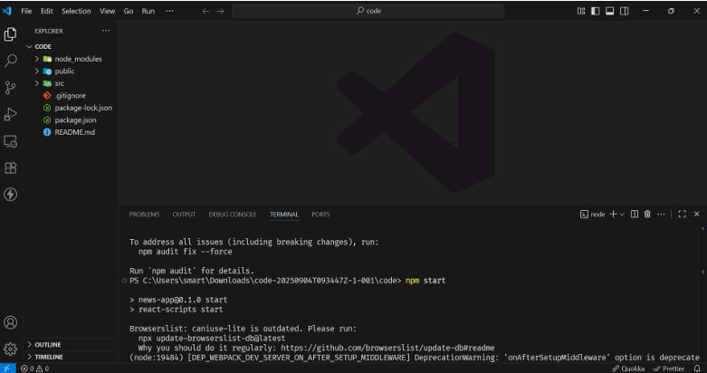

* Now your application will be opened in your browser with url http://localhost:3000

**5.Folder Structure**